- Assignment 1: Basic SQL
Statement: Write the simple SQL queries on the given schema.
- Write the following simple SQL Queries on the University Schema.
- Find the names of all the students whose total credits are greater than 100 .
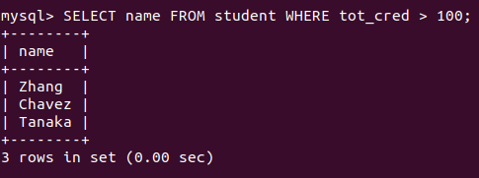

- Find the course id and grades of all courses taken by any student named 'Tanaka'.
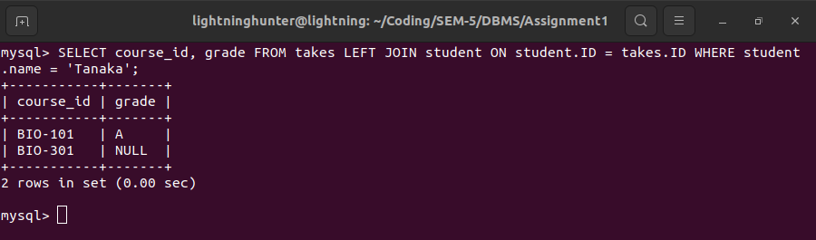
- Find the courses which are offered in both 'Fall' and 'Spring' semester (not necessarily in the same year).
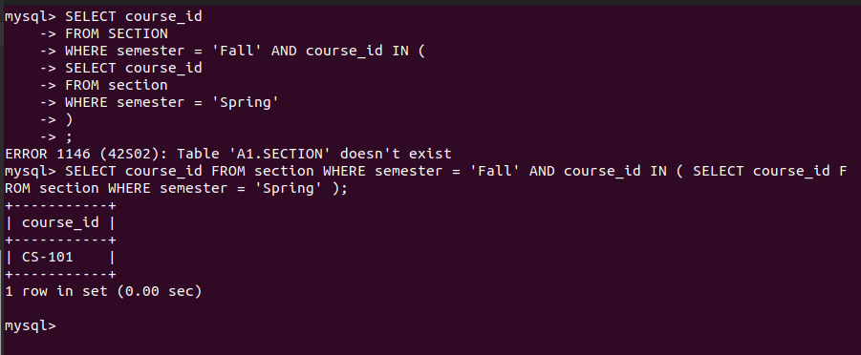

- Find the names of all the instructors from Comp. Sci. department.
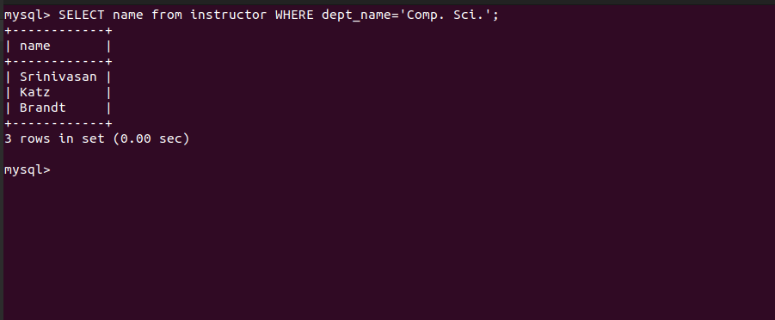
- Find the course id and titles of all courses taught by an instructor named 'Srinivasan'
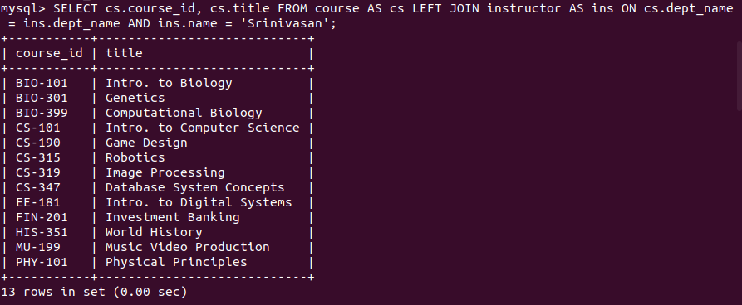

- Find the names of instructors who have taught at least one course in Spring 2009.
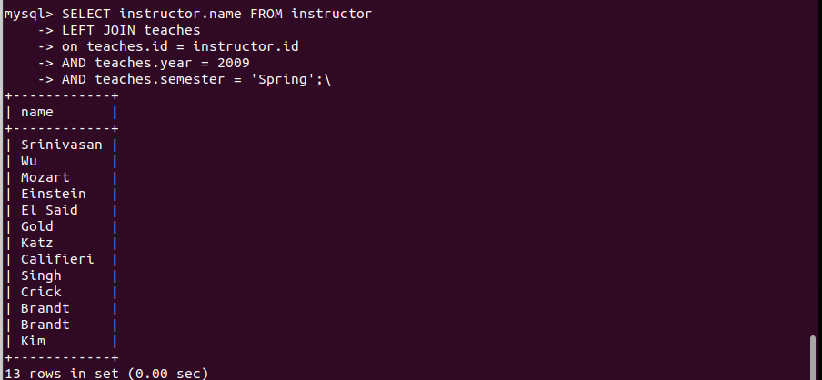
- Create the Railway schema using the commands in the Railway DDL script; The DDL script also contains a description of the railway Schema. Insert sample data using the command in the file SampleRailwayData.

Write the following Queries for Railway Schema.
- Find pairs of stations (station codes) that have a track (direct connection) with distance less than 20Kms between them.
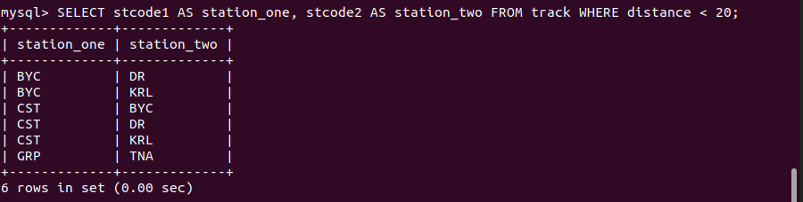

- Find the IDs of all the trains which have a stop at THANE

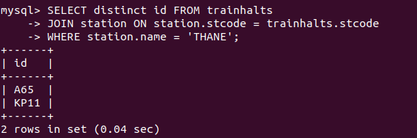
- Find the names of all trains that start at MUMBAI.
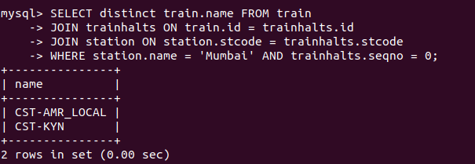

- List all the stations in order of visit by the train 'CST-AMR_LOCAL'.

